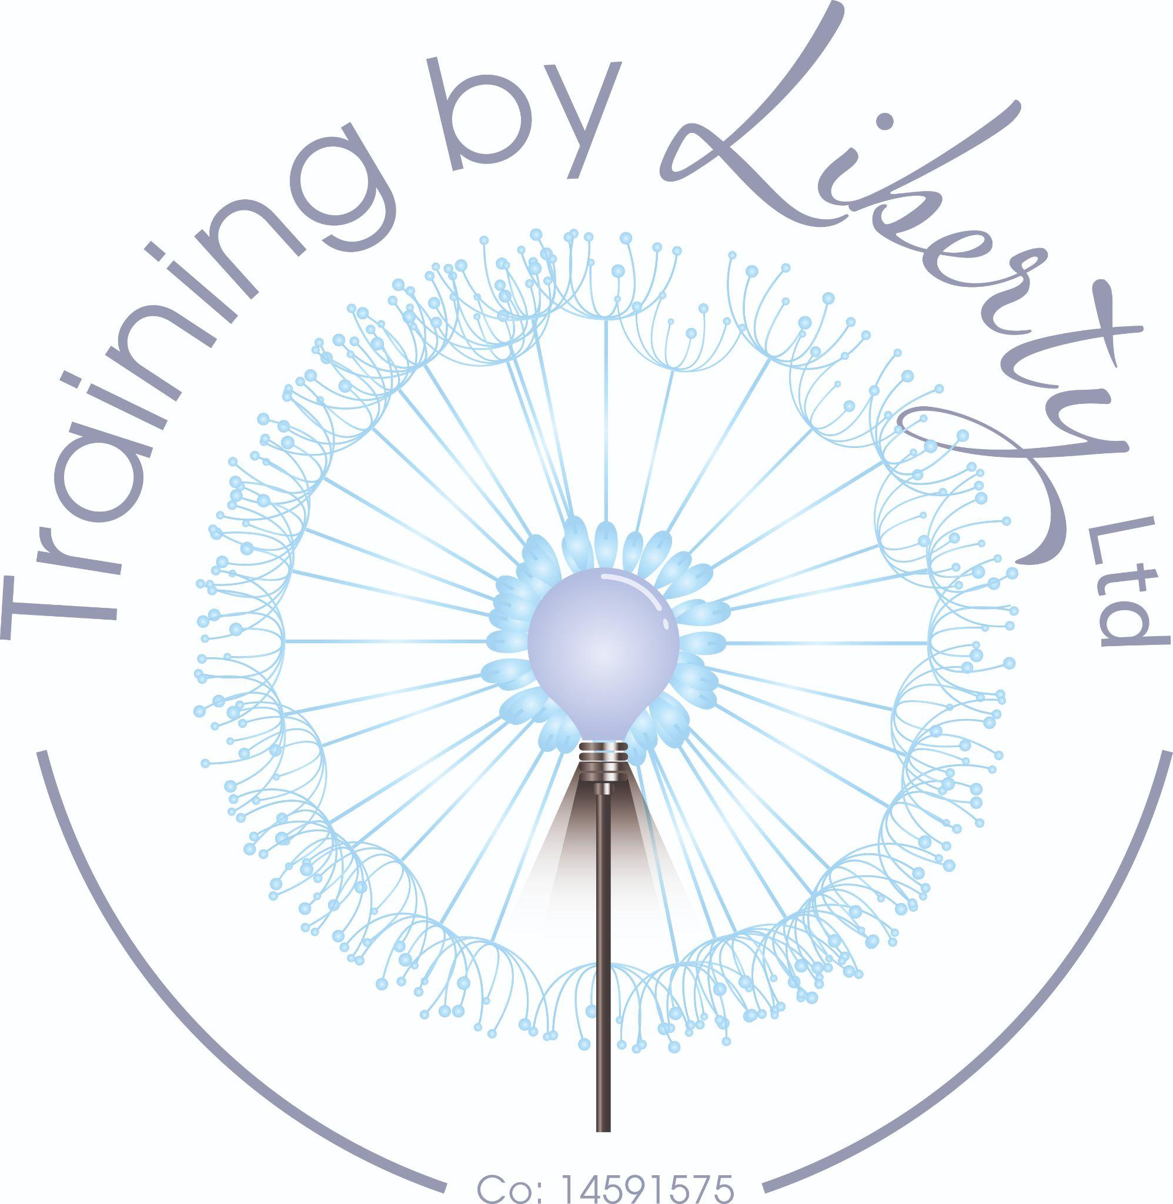

Training By Liberty Newsletter

Exciting times ahead!


by Catherine Drewer, Director March 2025
We are delighted to announce not only the return of our counselling training to become a qualified therapist but we are able to offer some really interesting and useful CPD that will expand your knowledge and positively impact your practice.
We have a new section aimed at supporting supervisors too! There is not enough Supervisor focused CPD available and we hope we have made headway into that.
We really hope to see you at some of our workshops soon
Catherine
Become a Counsellor

Introduction to Counselling
by Training By Liberty Limited
Becoming a counsellor is a big commitment of both time and money. Our Introduction course is designed as a dip your toe in course that will allow you to experience what learning counselling is all about and decide whether you are able to commit the time and money to complete the training.
This course is aimed at anyone interested in counselling on any level. Anyone who is just wondering what counselling is or someone who has signed up for counselling training that is coming up and just curious what it might be all about.
Introduction to Counselling is designed to give you basic information about counselling. Course participants will investigate what counselling is; learn about theory; practice some skills and consider what comes next for them. It is designed to be interactive with a variety of theory, personal investigation and application in real life through learning from others and discussion
Course is 5 weeks and successful completion allows you to have priority onto our Certificate in Counselling Skills (NCPS Quality Checked)
Face to face 6:30pm - 9:30pm beginning Wednesday 4th June - Cost £225
Course registration form: https://forms.gle/WdtFBQyV2LJgJRMw9



Certificate in Counselling Skills (level ⅔ equivalent) - NCPS Quality Checked Status
by Training By Liberty Limited
The course is run over 30 weeks, giving you 90 hours of face to face training and will provide you with the tools and knowledge that will help you feel prepared to embark on the final leg of becoming a counsellor. The core model of the course is Person-centred as this is a model that is built on the relationship between counsellor and client, but you will also be taught some Cognitive Behavioural and Psychodynamic Theory to provide a well-rounded understanding of theory.
Module 1: Working ethically in helping relationships: This module investigates what counselling is along with exploring ethics, an important aspect of becoming a counsellor in practice.
Module 2: Understanding different theories of counselling. This module will provide theoretical knowledge of the 3 major schools of counselling theory, Psychodynamic, CBT and Humanistic
Module 3: Developing and practising counselling skills: This module will allow development of basic counselling skills
Module 4: Working with difference and diversity: To ensure that the learning is relevant and inclusive you will investigate the Equality Act 2010 along with considering your own relationship with difference.
Module 5: Understanding the importance of self, and personal development: This module will allow understanding of who you are and how that may impact working with clients.
The assessments include:
- Essays
- Presentations
- Skills sessions
- Classroom participation
- Group work

You will have access to course materials through Google Classroom throughout the duration of your course.
Face to face 6:30pm - 9:30pm beginning Wednesday 10th September £900
Interest free payments available
Registration form: https://forms.gle/WdtFBQyV2LJgJRMw9
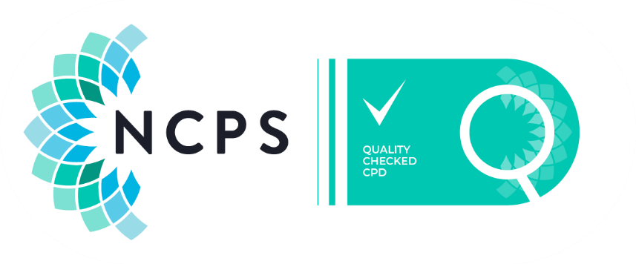

NCPS Accredited Counselling Practitioner Diploma (Level 4 equivalent)
by Training By Liberty Limited
The course is run over 2 years, giving you 360 hours of face to face training (over 18 months) and will provide you with the tools and knowledge that will help you feel prepared to work ethically as a counsellor. The core model of the course is Person-centred as this is a model that is built on the relationship between counsellor and client, but you will also be taught some Cognitive Behavioural and Psychodynamic Theory to help you discover the counsellor you would like to be post qualification.
The modules studied will be – Working Professionally and safely as a counsellor; working within a coherent framework of counselling theory and skills; working within a counselling relationship; working with client diversity in counselling work; working with self-awareness in the counselling process; working self-reflectively as a counsellor; and the placement module Working within a user-centered approach to counselling which includes your placement of 100 supervised placement.
Your course fee also includes a standalone training on the Safeguarding Legislation which is a must for any would be counsellors and unique to Training By Liberty
Entry requirements: Certificate in Counselling Skills minimum Level 3 equivalent that contains a minimum of 90 hours face to face learning.
Face to face 6:30pm - 9:30pm beginning Tuesday 9th September £4250
Interest free payments available
Registration form: https://forms.gle/oXYPzGXDEot55u2DA

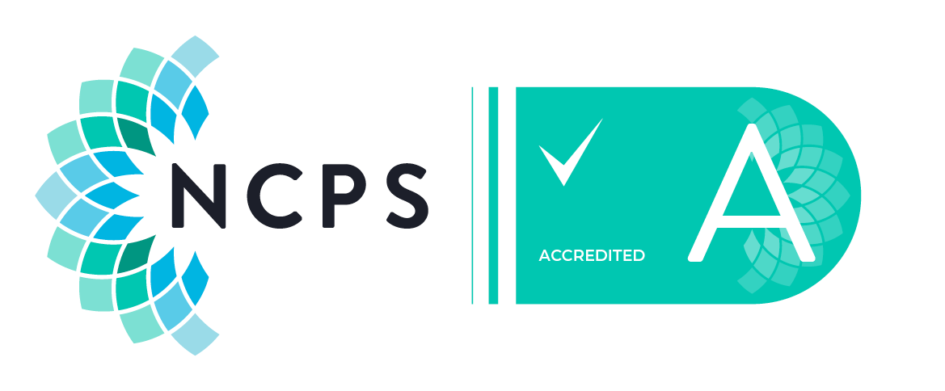
CPD Courses



Understanding Adoption Legislation
by Catherine Drewer
Working with adopted and looked after children remains the only aspect of working as a counsellor that is protected under the law. This is something that counsellors are taught but what does that actually mean? Which laws? How do they impact client work?
If you are a counsellor considering working in private practice or in a school this is a vital piece of knowledge that will help you to feel more comfortable about whether or not to work with a client and where to reach out for support
Cost: £50 3 hours CPD certificate provided and materials available through Google Classrooms for you to retain
Face to face April 12th 9:30am - 3 hours
please complete the registration form here: https://forms.gle/ZbAUXZJ9NsTApNTf6

Working with Trainees - Supervisor CPD

by Catherine Drewer
Often when we first train as Supervisors we work with Trainees because we can offer reduced rates and they are good steady income however, working with trainees has many pitfalls and responsibilities that can trip the unsuspecting up as they go.
To help support your counsellors more effectively and safely this 3 hour CPD explores what Supervisors need to bear in mind, where responsibility for ethical practice lies, what 3rd party considerations need to be explored and other general trip hazards in this work.
The aim is to ensure that Supervisors are confident in working with Trainees as it is the most rewarding work and the place that we can do the most good
Face to Face: Saturday 24th May, 9:30 to 12:30 £50
Registration form: https://forms.gle/6GtJCJzESt92oW7h9

Navigating your Shadow Side
by Keeley Salmon

“Navigating Your Shadow” is a comprehensive 3-hour CPD course designed to help you explore and integrate the hidden aspects of your psyche.
Shadow work is a powerful tool for personal growth and self-awareness. This course will guide you through the process of identifying and understanding your shadow, the parts of yourself that you may have repressed or denied. By the end of this course, you’ll have practical strategies to navigate your shadow and integrate these aspects into your conscious self.
This course is ideal for counsellors as well as anyone interested in exploring their inner self.
Face to Face: Saturday June 14th, 2025 9:30 - 12:30 cost £70
Registration form: https://forms.gle/3Epp8H9ec8VkXDoh7
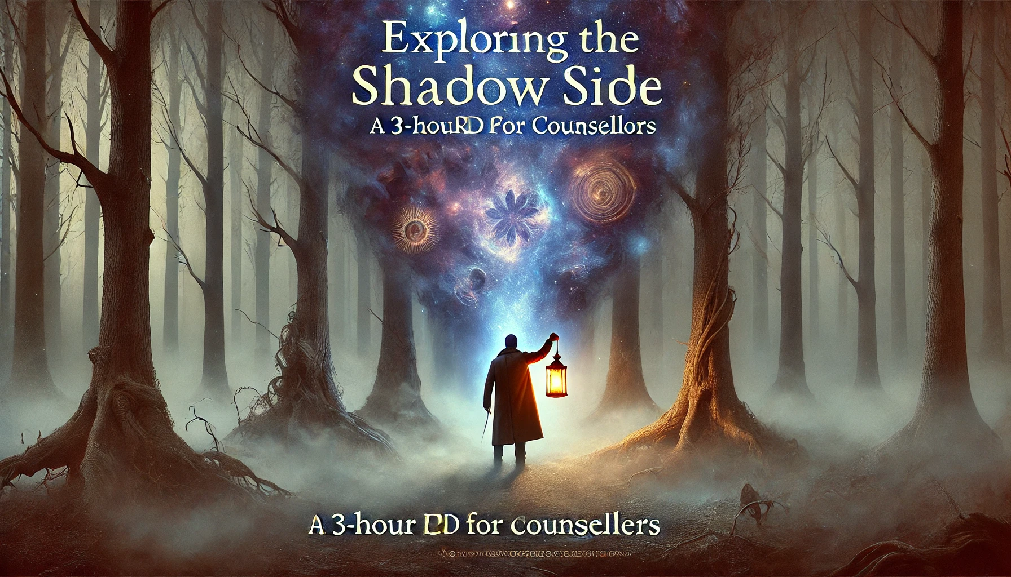

Emotional Wellbeing 4 week course
by Keeley Salmon
I cannot recommend this course highly enough. As therapists we believe we understand feelings and emotions because it is vital for what we do right? Well, it turns out – there is so much more to it than we thought.
This thoroughly thought provoking and informative training is delivered by Keeley, our wonderful core tutor who has explored way beyond her core training and added depth and passion to what she has learned and now shares with us.
This course is a short learning journey in exploring and understanding emotions. A course that is perfect not only for counsellors but for anyone wanting to understand what it is to be an emotional human being.
You will be exploring and understanding emotions through the lens of Positive Psychology. Its purpose is to develop emotional intelligence, agility, and wellbeing, by understanding the important role emotions play in how we think, feel, and behave. It will educate on the importance of emotional self-awareness and regulation whilst developing ways to build emotional resilience, cultivate more positive emotions, and discover how to use our emotions for motivational purposes.
Workshop 1: Emotional Wellbeing
Workshop 2: Emotional Classification
Workshop 3: Emotional Resilience
Workshop 4: Emotional Eudaemonia
Face to Face learning in Rochford beginning Wednesday 4th June 6:30pm to 9:30pm for 4 weeks - Cost: £250
A very popular course that fills fast -
registration form https://forms.gle/LFdyUkweLzGLaZDY6

TA2: Exploring Personality Adaptations
by Catherine Drewer
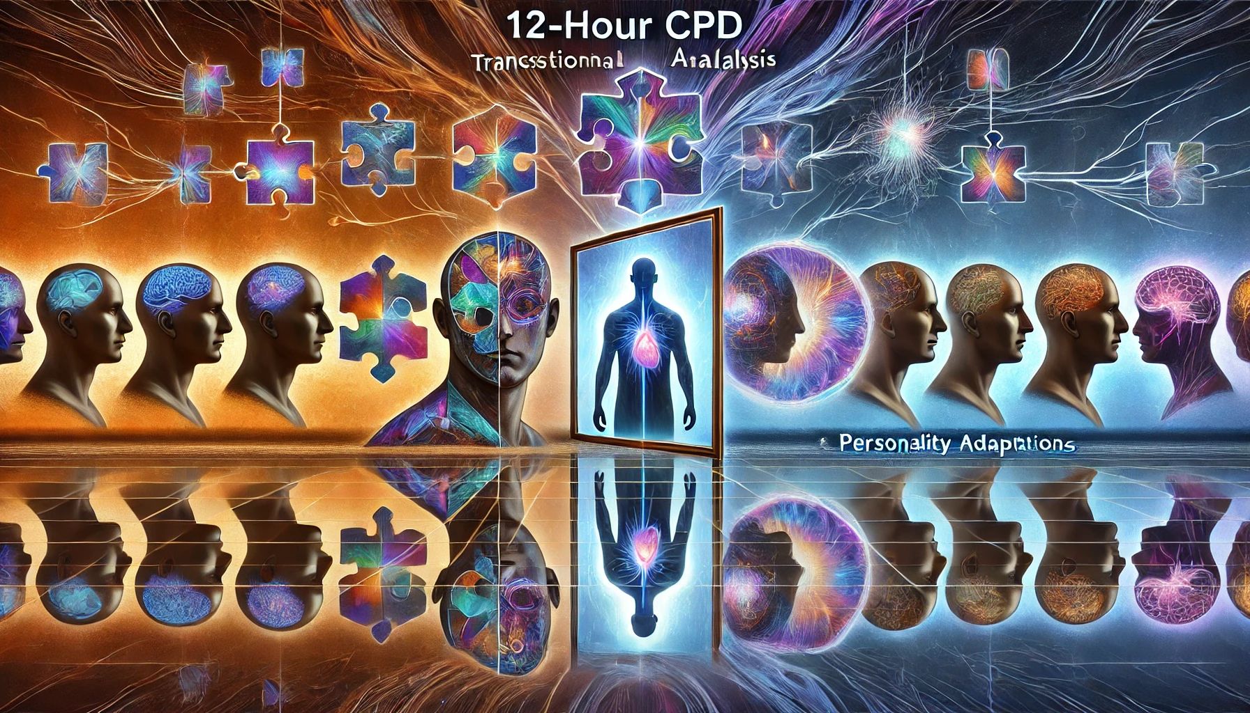
Suitable for those that have completed our Introduction to TA or the TA 101, this course will delve into Personality Adaptations and how understanding them can help with client work and with understanding self.
As always, TA is an exciting theory that is visible in ourselves and our clients and really helps to explore communications and connection with others.
Everyone should learn TA
Monday 16th June for 4 weeks. Full price £440 early bird £325 (before April 30, 2025)
Email info@trainingbyliberty.com for a registration form

Safeguarding Legislation
by Katy Parsons
Understanding Safeguarding Legislation is vital for ethical practice and whether you work in private practice or in an agency, better understanding of the Safeguarding Legislation and how it applies in practice will support you in feeling safe to work with risk.

This course is aimed at counsellors in practice or those in training who work with clients. When we think of safeguarding, we think of working with Children and Young People but there is so much more to safeguarding than children.
The information provided is relevant to any work a counsellor may do and therefore is relevant to all. If you are supervising counsellors, then it is vital you understand safeguarding legislation and procedure, and this is a great course to provide the knowledge you might need. Counsellors who work in schools know that they should report to the Designated Safeguarding Lead but what do they do with the information you provide and are counsellors allowed to follow up or make further referrals if they still have concern?
This full-on day of training will include group discussion, understanding of the law in relation to Safeguarding Children, Adults and others. It will include introduction to PREVENT Awareness and help to broaden understanding on what raising a safeguarding concern means. We will culminate the learning with a practical application of the knowledge to real life counselling practice.
Face to Face learning in Rochford
Saturday 21st June 9:30am to 3:00pm Price: £80 student rate £60
Registration form: https://forms.gle/vvvNnDTitjuyfi3Y9

Blocks to Safeguarding
by Catherine Drewer

If you have completed our Safeguarding Legislation training and want to add to this then this is the course for you.
A 3 hour CPD that will explore our biases, assumptions and fears when thinking about client risk. Working with other practitioners really helps to expand perspective and understanding and can only lead to more robust Safeguarding practice

Saturday 28th June 2025, 09:30 - 12:30 £50
registration form: https://forms.gle/uXBfphvUTkowTUJs7

Ethical Decision Making Process
By Catherine Drewer
This course is designed for Supervisors and Counsellors to help ensure you have good decision making processes in place long before you may need them.
We explore what makes an ethical decision making process and how to put this in action with reference to ethical body guidelines and best practice. Making any choices about what to do next with clients deserves to have scaffolding around it so you can be sure of why you made the choice you did.
Face to face, Thursday 24th July 6:30pm £50
Registration form: https://forms.gle/uXBfphvUTkowTUJs7

Discovering Inner Patterns: Archetypes
By Keeley Salmon

Unlock the secrets of Carl Jung's archetypes and explore how they influence your behavior and personal growth in this engaging 3-hour CPD course.
Starting with an introduction to archetypes and their significance, you'll explore their presence in the personal and collective unconscious. As the session progresses, you'll dive deeper into individual archetypes such as The Hero, The Outlaw, and The Caregiver, and discover how they appear in myths, stories, and everyday life.
Finally, apply your insights through self-reflection, identifying your own dominant archetypes. This process fosters self-awareness, personal development, and therapeutic understanding. Through a blend of guided activities and group discussions, this course equips you with practical tools to integrate archetypal knowledge into your everyday experience
Face to Face, Wednesday 23rd July 2025 6:30pm - 9:30pm £70
Registration form: https://forms.gle/R9z4fv4NxRU8byis8



Safeguarding In Practice
by Catherine Drewer
When we learn to be counsellors we explore safeguarding in our training and in our placement but we rarely consider what it really means in practice. This 3 hour CPD is designed to explore how to put good safeguarding practices into action so that you feel secure in your processes and supported in your practice.
As a Supervisor this is an invaluable opportunity to explore what your supervisees, and yourself need to have in practice to align with your ethical bodies requirements and promotes safe practice for you all.
Safety Plans and risk assessments will be explored in relation to client case studies; ensuring that rich learning is experienced from other practitioners in your study
Face to Face, to be confirmed
Email info@trainingbyliberty.com to register your interest

Introduction to TA 6 week course
by Catherine Drewer
A great introduction to Transactional Analysis allowing you to explore yourself and your clients from a slightly different perspective. Everyone that completes this training has a powerful reaction to the observable aspects of the theory, it makes sense for them and for the client's work. TA provides a great new language to explore self that really resonates with counsellors as well as clients.
You will definitely learn something new about yourself and recommend considering doing this if you just want to explore yourself more too.
6 weeks of study that culminate in theory in practice
Thursday 9th October 2025 x 5 and 1 Saturday full price £660 early bird £525 (before July 2025)
Registration form: https://forms.gle/mkvQ6dxvBcU4WEyv5

TA2: Exploring Personality Adaptations
by Catherine Drewer
Suitable for those that have completed our Introduction to TA or the TA 101, this course will delve into Personality Adaptations and how understanding them can help with client work and with understanding self.
As always, TA is an exciting theory that is visible in ourselves and our clients and really helps to explore communications and connection with others.
Everyone should learn TA
£440 dates to be confirmed
Email info@trainingbyliberty.com to register your interest

Working with Children and Young People: A workshop
This short course explores the differences between working with adults and working with Children and Young People. It is ideal if you are considering undertaking additional training to work with Children or if you are a student who is about to go out into placement and would like to be armed with a more robust understanding of this topic.
Delivered by our director Catherine, who is an Accredited Children and Young People Counsellor, Supervisor and Adoption Support Counsellor this training includes rich real-life experiences so you can understand the theory in practice
Monday 8th September 2025 £50
Registration form: https://forms.gle/H4YMgZEC3LfVCUXx5
once you have completed the short course, why not consider the Advanced Specialism in working with Children and Young People

Advanced Specialisms

As a qualified counsellor it is important to continue our learning and work on Specialisms that support your practice. Training By Liberty offers Working with Children and Young People, and Supervisor Specialisms that provide robust knowledge and experience to help you support your developing career.
Our tutors are experienced and practicing therapists who have teaching and learning qualifications.
These courses have been awarded Advanced Specialist Status by the NCPS

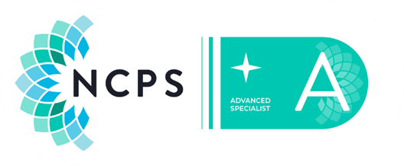

Advanced Specialist: Working with Children and Young People
The course gives you 60 hours of face-to-face training and will provide you with the tools and knowledge that will help you feel prepared to work ethically with this client group. If you work in school and have done predominantly adult training, then this is the course for you.
It is a robust 20 weeks that teaches you the stuff you did not know you needed to know and along with our Safeguarding course will help you to feel more secure in the work you do with these clients.
This course will consider the following areas of working:
Module 1: Applying Theory to practice: exploring attachment, TA, Person-centred and behaviourial theories.
Module 2: Developing reflective practice:
Module 3: Ethics and Young People: Risk assessments, safety planning and understanding how to be safe.
Module 4: Working Creatively: exploring powerful ways to develop a creative lean in your work
Module 5: Loss and Attachment: Understanding how this client group experience loss, the language they may use and how their attachment style may affect how they process loss.
Module 6: Research proposal: exploring an area of this work that you are interested in developing knowledge around.
Begins Monday 15th September 2025 for 30 weeks £975 (payment terms offered)
Registration form: https://forms.gle/q14xvZDgadC7MhLz9



Advanced Specialism: Supervision
by Catherine Drewer
Ever thought of becoming a Supervisor? Or just wondered what supervision entails then this is the course for you.
The course is run over 20 weeks taught session and 10 weeks for study, giving you 60 hours of face to face or online training (synchronous)
Unlike other supervision training this course is designed to provide a depth to your knowledge that includes not only more than 3 theoretical models of supervision but also reflective practice and ethics, along with the opportunity to further investigate an area of counselling and supervision that really interests you.
The modules studied will be – Understanding theory and frameworks of supervision, applying theory to practice, research methodologies and reflective approach to being a supervisor.
Face to Face 30 weeks (term time) beginning Tuesday 9th September 2025 - Cost £975 interest free payment options available
Registration form https://forms.gle/MSULJGvsWuf4N7zm9



READ MORE ON OUR WEBSITE
Training By Liberty Ltd
Rochford, Essex

